2016

*How to use Internal Tools*

Gregg Bursey

Scout Software Engineering

Table of Contents

1 User Management 3

2 Logo Management 3

3 Profile Management 5

# Company Management

1. *How to change a company’s expiration date*

Select the company from the main search and then go to Company Overview. On the details card, click the **Change** button:

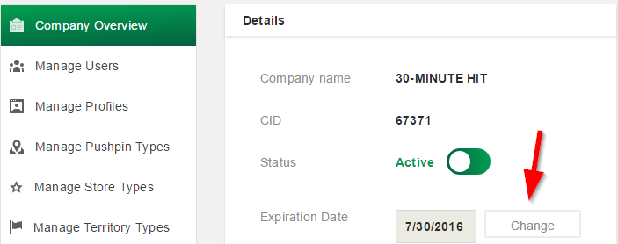

The dialog will pop up.

Use the dropdown to change the date to whatever it needs to be:

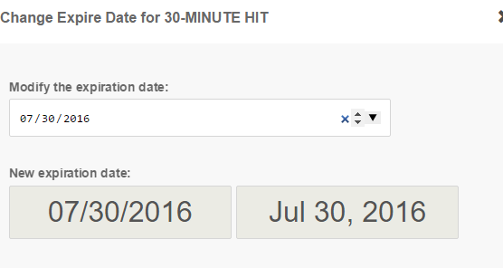

Click the confirm button to save that date.

1. *How to inactivate a company*

When you’ve selected your desired company, simply toggle the status of the company by clicking this button:

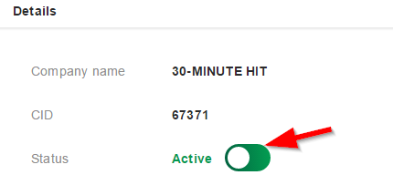

# User Management

1. *Clear all sessions*

If a user calls in saying that they’ve tried logging in and then get a “Too many devices logged in” message, go to that company, select *Manage Users*, and click this button:

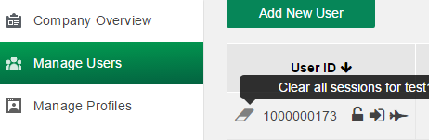

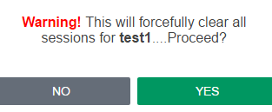

On the popup, click Yes. This will log out **everyone** that is using that ID.

1. *How to activate / inactivate a user*

Under *Manage Users*, find the user you want and use the toggle to activate or inactivate the user. Inactive users will not be able to login to the Platform.



1. *How to inactivate a company*

a

1. *How to inactivate a company*

a

# Logo Management

Platform > Company Dashboard > select your company > Details card.

If a logo is missing, you will see this:

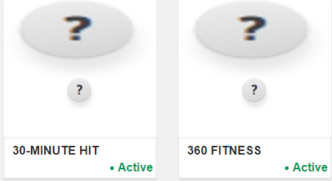

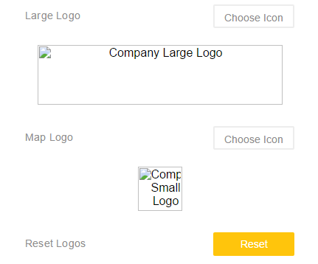

*Upload a new icon*

*Large Path*: X:\SCOUT\Icons\lg – 331x811

*Small Path*: X:\SCOUT\Icons\sm – 60x60x

***\*\*NOTE\*\****: **DO NOT** upload images that have not been formatted for SCOUT as they may appear in an undesirable way on the platform (i.e. – even if a customer sends you an image to upload, it must be formatted by Todd Piersall before being uploaded).

***\*\*NOTE\*\****: Images must be in .PNG format.

Click the “Choose Icon” button for large or small. Choose the appropriate icon from the Large Path or Small Path. Ensure the preview is the image you selected. Click OK to finish. This updates the logos that you see in the platform:

For Large:

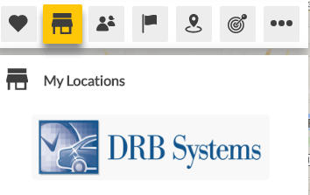

For Small (map icon):

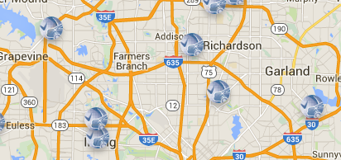

Small also appears in MyData:

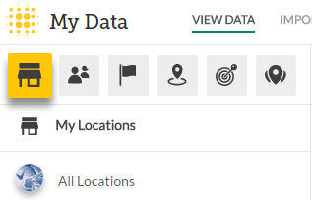

*Resetting images*

If the wrong image is uploaded or a mistake was made in some way, use the Reset button. This will change both their large and small image to the “missing” image.

# Profile Management

1. *How to add a new Profile*

Select your company and then select ‘Manage Profiles’:

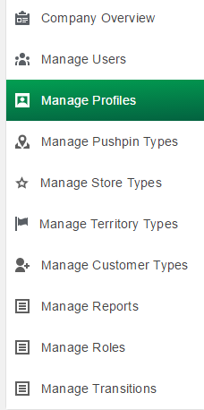

Select Add New Profile:



Give the profile a name, determine whether it’s overall, primary, secondary, or tertiary, and select the needed segments.

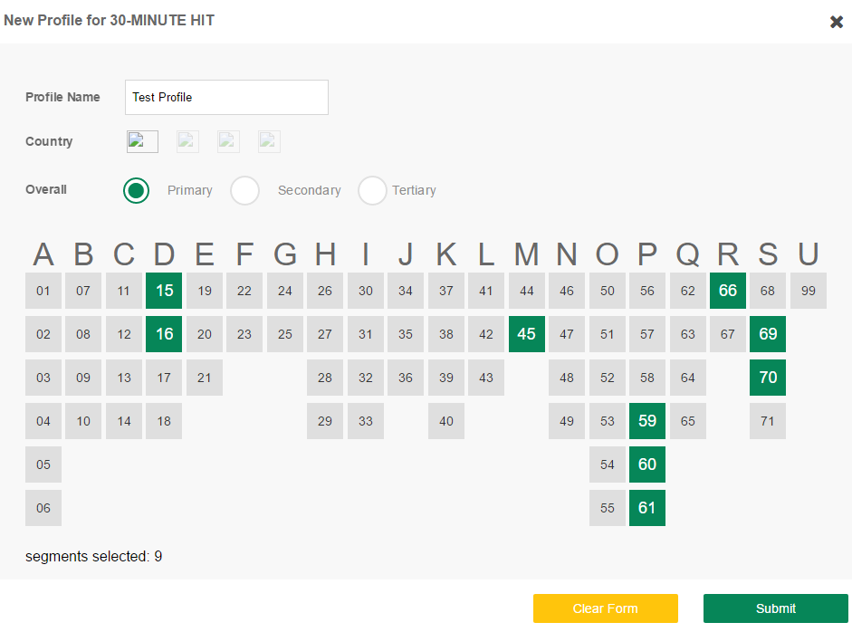

Submit the profile when complete.

Profile will appear in the list for that company. Use the “Active” toggle to turn on or off for a client.

